Project Charter
Project Title: Case Studies to Video Generator
Date: January 19, 2026

1. Executive Summary
A high-level snapshot of who is doing what and when. This project aims to deploy a fully automated pipeline that converts static text PDFs into dynamic 64-second videos using AI orchestration and browser automation.
Role | Who | Start Date | End Date
Responsible (Owner) | Group 7 | Day 1 | Day 6
Data and Automation Engineer | Shruti Gupta, Vaishnavi Zope, Vishwa Pethani | Day 1 | Day 6
Marketing and Content Executive | Pratik Motwani | Day 1 | Day 6

2. Purpose

2.1 Project Background (The "Why")
Context: Currently, converting a written case study into a video asset requires manual scriptwriting, storyboard creation, and video editing.
Problem: This manual process is time-consuming and creates a bottleneck in our content marketing pipeline.
Opportunity: By leveraging n8n for orchestration and BrowserUse for interacting with generative video tools (Flow AI), we can reduce production time to near-zero human effort.

2.2 Project Objective (The "Goal")
Objective: Develop a locally-hosted automated workflow that monitors a Google Drive folder for input assets (PDF + 2 Logos) and converts them into a 64-second video.
Key Technical Requirement (The "3-Layer Prompt"):
The system must generate prompts that explicitly combine three distinct layers for every scene:
- Global Style Token: A merged string containing:
  - Static: Our Company's Theme Guidelines (Stored locally/static).
  - Dynamic: Case Study Company's Theme (Extracted via LLM).
  - Atmospheric: Lighting, Tone, Camera Angle.
- Visual Template: Defines spatial layout (e.g., "Our Logo bottom-left", "Client Logo top-right", "Text overlay top-center").
- Scene Action: The specific visual narrative for that 8-second segment.

2.3 Customer Benefit (The "Value")
- Marketing Team: Saves ~5 hours of manual work per video asset.
- Brand Consistency: Ensures every video follows the exact same "Style Token" and "Visual Template" via the new Brand Guardian agent.

2.4 Technical Workflow (Process Logic)
The automation must strictly follow this sequential flow:
- User Input: User uploads 3 files to a specific Google Drive folder: Case Study PDF, Company Logo (PNG), and Client Logo (PNG).
- Prompt Generation: n8n fetches the files. It reads the PDF and uses an LLM to generate 8 distinct "Scene Prompts."
- Parallel Theme Extraction: Simultaneously, n8n uses an LLM to extract the "Client Company Theme" from the PDF.
- Static Asset Retrieval: n8n retrieves the static "Our Company Theme" and "Visual Template" definitions.
- Combination & Verification: n8n merges the [Global Style Token + Visual Template + Scene Prompt] into 8 final prompt strings. The Prompt Auditor Agent then cross-verifies these final strings against the brand guidelines.
- Payload Handoff: n8n sends the 8 verified prompts and the 2 logo file paths to the BrowserUse script.
- Browser Execution: The BrowserUse agent (Python) logs into Flow AI and inputs each prompt one by one.
- Video Capture: BrowserUse waits for generation and saves the finished video file.
- Delivery: The final video is uploaded back to the same Google Drive folder for user review.

3.1 Work Breakdown Structure (WBS) & Roadmap
This timeline is strictly compressed to a 6-day sprint.
WBS ID | Task/Milestone Name | Task Type | Dependency | Responsible | Start | End | Deliverable
1.0 | MILESTONE: Logic & Agents Implementation | Sequential | - | Group 7 | Day 1 | Day 3 | Verified Prompts
1.1 | Project Planning & Environment Setup (Local) | Sequential | - | Shruti Gupta | Day 1 | Day 1 | Approved Charter
1.2 | n8n Setup: Google Drive Trigger & Asset Parsing | Sequential | 1.1 | Vishwa Pethani, Vaishnavi Zope | Day 1 | Day 2 | Drive Watcher Node
1.3 | Parallel Agents: Theme Extraction & Static Retrieval | Sequential | 1.2 | Pratik Motwani (Logic), Shruti (Dev) | Day 2 | Day 2 | Global Token JSON
1.4 | Scene Prompt Agent: Generation | Sequential | 1.3 | Pratik Motwani | Day 2 | Day 3 | 8 Raw Scene Prompts
1.5 | Prompt Combination & Auditor Agent | Sequential | 1.4 | Vishwa Pethani, Vaishnavi Zope | Day 3 | Day 3 | 8 Verified Final Prompts
2.0 | MILESTONE: Browser Automation & Integration | Sequential | 1.5 | Group 7 | Day 4 | Day 6 | Working Prototype
2.1 | Python Browser Agent: Flow AI Interaction | Sequential | 1.5 | Vaishnavi Zope | Day 4 | Day 5 | Working Script (Local)
2.2 | Integration: Connect n8n Agents to Python Script | Sequential | 2.1 | Shruti Gupta | Day 5 | Day 5 | End-to-End Flow
2.3 | User Acceptance Testing (UAT) | Sequential | 2.2 | Pratik Motwani | Day 6 | Day 6 | UAT Feedback Log
2.4 | Final Code Refinement & Buffer | Buffer | 2.3 | Group 7 | Day 6 | Day 6 | Final Local Codebase

3.2 Flowchart:
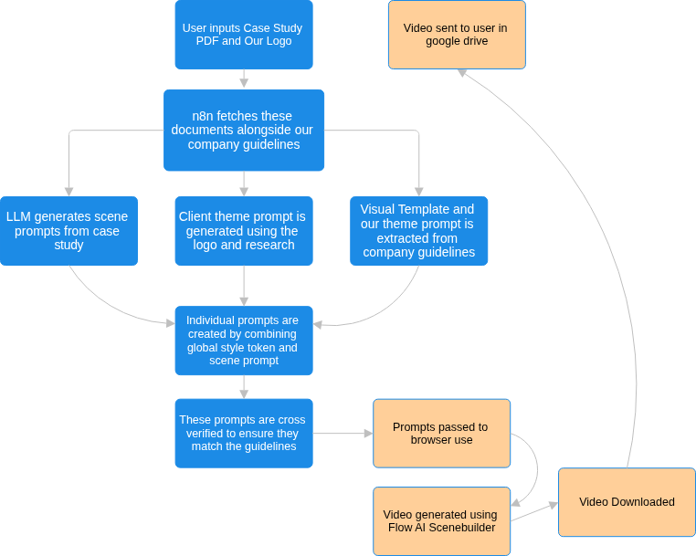
.

4. Project Details

4.1 Scope (In vs. Out)
In Scope:
- Input Trigger: Google Drive Folder Watcher (Must detect 3 files: 1 PDF Case Study, 1 Company Logo PNG, 1 Client Logo PNG).
- Advanced Workflow: Includes "Brand Guardian" (Token/Template generation) and "Prompt Auditor" (Compliance check) agents.
- Output: Final Video uploaded back to the Google Drive Output folder.
Out of Scope:
- Video Editing: No post-production (music syncing, voiceover adjustments).
- Public Access: The tool will only be accessible to the developer running the localhost server.

4.2 Budget
- Software Subscriptions:
  - Google AI Pro Plan (Incl. 1000 Monthly Credits): ~₹1950/month
  - n8n: Free (Self-hosted Desktop Version).
- Labor: Internal Developer hours.

4.3 Resources
- People:
  - Data and Automation Engineers: Shruti Gupta, Vaishnavi Zope, Vishwa Pethani
  - Marketing and Content Executive: Pratik Motwani
- Tools:
  - Storage/Trigger: Google Drive (Shared Folder).
  - Orchestration: n8n (Desktop Version).
  - AI Logic: Google Gemini.
  - Browser Agent: browser-use Python library + Headless Chromium.
- Infrastructure: Local Development Machine (High RAM required for running Browser + n8n + AI).

4.4 Risks
Risk Description | Impact | Mitigation Strategy
Input Asset mismatch: User uploads PDF but forgets the logos, or names them incorrectly. | High: Workflow fails to generate the "Visual Template." | Mitigation: Add an n8n logic node that checks for all 3 files before starting. Send an error alert if files are missing.
Agent Complexity: Adding two extra agents (Guardian & Auditor) increases latency and error points. | High: Workflow might timeout or become too slow. | Mitigation: Run agents in parallel where possible, or use "Flash" models for the Auditor agent to save time.
Flow AI UI Changes: The video generation site changes its button layout. | Critical: Script failure. | Mitigation: Hardcode selectors for the specific 6-day sprint duration; worry about robustness in Phase 2

4.5 Communication Plan
- Daily Stand-up: 10-min sync every morning (Days 1-6).
- Immediate Bug Reporting: Direct message in Group Chat for any blocker.

4.6 Final Success Measurement
The project is considered complete when:
- The "Brand Guardian" successfully extracts a Style Token and merges it with the 2 Logo assets.
- The "Prompt Auditor" successfully approves valid prompts and rejects invalid ones.
- We have generated 3 consecutive videos locally using the 3-file input method without manual intervention.

4.7 Future Plans & Sustainability
- Phase 2 (Priority):
  - Application Scaling: Enable generation of 2-3 minute videos.
- Phase 3:
  - Automation tool to be able to post the Youtube videos with appropriate title and description.

